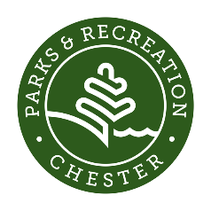
Chester Park and Recreation Financial Aid Policies and Procedures
(Revised March 2024)
- All fee-based Park and Recreation programs shall be made available to Chester residents through our online Recdesk portal: http://chester.recdesk.com
- Residents registering for programs shall use this portal, with support and guidance from the Park and Rec department as needed.
- All fee-based Park and Recreation programs shall have financial aid available for Chester residents, contingent upon the availability of sufficient funds in the Chester Community Fund.
- Procedure for residents to apply for financial aid:
  - Step 1: Any resident that is interested in applying for financial aid shall contact our Human Services department: humanservices@chesterct.org
  - Step 2: Human Services determines financial aid status based on family income.
  - Step 3: If financial aid need is demonstrated, the following amounts shall be given:
    - Summer Camp: Up to a maximum of $300 per child awarded. This represents 3 sessions of camp at 50% of the cost.
    - School Year Programs: Up to 50% of the total fee per program per child (for example, rec basketball at $100 per child would cost $50 per child).
    - Adult Programs: Up to 50% per program per adult.

- All financial aid recipients must adhere to the following guidelines:
  - Potential financial aid recipients must disclose information about their income and any caregiver income involved with their dependents.
  - Attend programs in which financial aid was awarded unless prior notice is given due to sickness, injury, etc. Reach out to the Park and Rec Director if you are unable to attend so that the space can be offered to other participants. Participants who fail to give notice and/or attend the program will be ineligible to receive financial aid for one year.

- For any clarifications, questions, or concerns, please contact our Human Services Department: 860-526-0013 x213 or humanservices@chesterct.org

